**Shapley - 5 Features (FI 0.80)**

Considering Shapley Feature importance values ≥ 0.80.

**Features:** FC3, Fz, F7, FT7, T4.

**Machine learning evaluation using 5 Features with Feature Importance ≥ 0.80.**

|  |  |  |  |  |  |  |
| --- | --- | --- | --- | --- | --- | --- |
| Algorithms | Accuracy | Precision | Recall | F1-score | AUC-ROC | Training Times (s) |
| KNN | 0.859115 | 0.877441 | 0.834708 | 0.855541 | 0.859105 | 0.95 |
| Random Forest | 0.838090 | 0.857018 | 0.811426 | 0.833599 | 0.838079 | 248.53 |
| XGBoost | 0.728109 | 0.755752 | 0.673744 | 0.712396 | 0.728087 | 3.74 |
| Decision Tree | 0.752920 | 0.754135 | 0.750238 | 0.752181 | 0.752919 | 8.68 |
| Extra Trees | 0.841864 | 0.874226 | 0.798477 | 0.834636 | 0.841846 | 83.00 |

**Table:** Machine learning evaluation using 5 Features with Feature Importance ≥ 0.80.

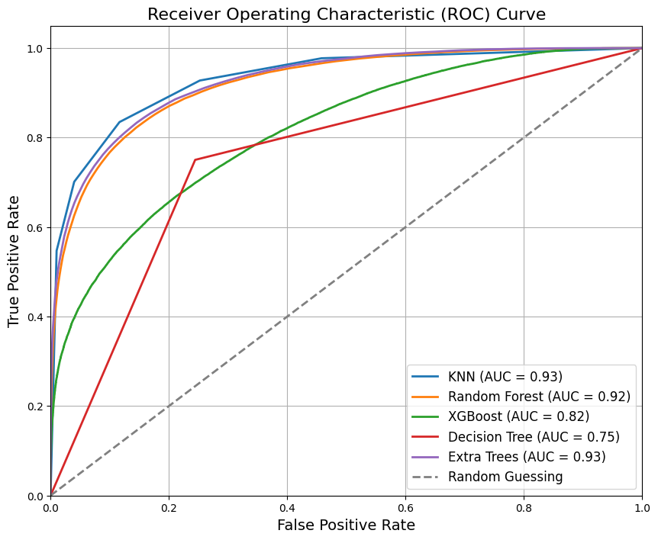

**Figure:** ROC Curve for Machine Learning Results using 5 Features with Feature Importance ≥ 0.80.

**Classification Reports – 5 Features**

**KNN:**

**precision recall f1-score support**

0 0.84 0.88 0.86 77676

1 0.88 0.83 0.86 77614

accuracy 0.86 155290

macro avg 0.86 0.86 0.86 155290

weighted avg 0.86 0.86 0.86 155290

**Random Forest:**

**precision recall f1-score support**

0 0.82 0.86 0.84 77676

1 0.86 0.81 0.83 77614

accuracy 0.84 155290

macro avg 0.84 0.84 0.84 155290

weighted avg 0.84 0.84 0.84 155290

**XGBoost:**

**precision recall f1-score support**

0 0.71 0.78 0.74 77676

1 0.76 0.67 0.71 77614

accuracy 0.73 155290

macro avg 0.73 0.73 0.73 155290

weighted avg 0.73 0.73 0.73 155290

**Decision Tree:**

**precision recall f1-score support**

0 0.75 0.76 0.75 77676

1 0.75 0.75 0.75 77614

accuracy 0.75 155290

macro avg 0.75 0.75 0.75 155290

weighted avg 0.75 0.75 0.75 155290

**Extra Trees:**

**precision recall f1-score support**

0 0.81 0.89 0.85 77676

1 0.87 0.80 0.83 77614

accuracy 0.84 155290

macro avg 0.84 0.84 0.84 155290

weighted avg 0.84 0.84 0.84 155290

**Confusion Matrix - 5 Features**

